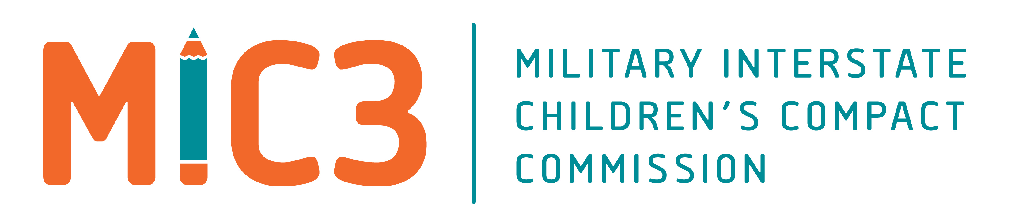

**Maine MIC3 Meeting**

**Virtual**

**1 November 2022**

FROM: Kristen Ferullo, ISLO - PNSY

TO: Pender Makin, NH MIC3 Commissioner

Sarah Forster, NH MIC3 Commissioner Designee

Commander Jeffrey Smith, USN, DOD MilRep, Maine

SUBJECT: Maine MIC3 Meeting Minutes

1. **PURPOSE**:

Child and Youth Education Services (CYES) execution authority is:

* NDAA, Section 1785 of title 10 United State Code
* OPNAVINST 1700.9 (series)
* Department of Defense Instruction (DODI) 6060.4, Youth Programs
* Department of Defense Instruction (DODI) 1342.44, Interstate Compact on Educational Opportunity for Military Children (MIC3)
* Navy School Liaison Officer Guide, 3 March 2009 Memorandum
* School Based Program Guide, February 2010 Memorandum

2. **IN ATTENDANCE:**

Sarah Forster, ME MIC3 Commissioner Designee

Commander Jeffrey Smith, USN Deputy Commander, Base Operations, PNSY

Jessica Nixon, Maine DOE, Chief of Operations

Scott Young, Deputy Commissioner, Maine DVEM

Joseph Baldacci, State Senate, District 9

Heidi Sampson, Maine State House of Representatives, District 21

Eric Waddell, Superintendent, Kittery Public School, ME

Brandi Cota, Military Family Education Liaison, Maine DOE

Elizabeth Marcotte, Lead Child & Youth Coordinator, Maine National Guard

Kristen Ferullo, School Liaison Officer, PNSY

**3. COUNCIL MEMBERS NOT IN ATTENDANCE:**

Jane Durgin, Director of Special Education, Kittery, ME

BG Douglas A. Farnham, MEANG, Adjutant General, Maine National Guard

4. **INVITED GUESTS:**

5. **Materials:** Agenda (see attached) Military Identifier Information & Resources

MIC3 Materials ME MIC3 State Law & Resources

School Liaison Resources

6. **DISCUSSION**:

a. Welcome & Introductions

b. Approval of previous meeting minutes 21 June 2022 (virtual)

- Minutes were approved unanimously.

c. Review of MIC3 National ABM

1. Compact Statute Citation Correction

a. Scrivener’s error in Compact model language needs to be changed to amend from the word “Section” to “Chapter” in outlined section/

b. Sarah Forster will work with legal and legislature to submit for the Errors & Omissions Bill in the next legislative session

2. National Guard & Reserves: National ABM vote for states to pass external legislation in support of NGR families to support their needs.

a. Sarah will reach to State Commissioners to see if they have model language passed in their states to serve as a template. As well as work with National office to see when General Council will have proposed legislative toolkit available for use.

3. Nationwide compliance at 100% for end of year reports

4. April 19, 2023 has been designated as Purple-Up Day

5. Highlighted new resources available on the website

6. Change in Rules verbiage to account for the “accredited” schools issue that Maine was part of with Hawaii this past year. Kristen will share updated Rules once published

7. Bloom for Military Teens: please share with your schools

8. Availability of presentations for ex-officio members and others available on [www.MIC3.net](http://www.MIC3.net)

d. Progress on Outreach for additional state council members

1. Work will continue in this are in preparation for the next meeting

e. Moving Forward

1. Council would like to have a joint meeting with New Hampshire hosted at Portsmouth Naval Shipyard

a. Proposed early May 2023

b. Kristen will reach out to Kathleen Murphy to confirm and organize

c. Sarah will look at funding for mileage/expenses with Jess Nixon

h. Other Issues/Questions

1. Kristen to email Senator Baldacci to discuss Purple Star Program

j. Adjourn: Meeting Adjourned at 1:47pm