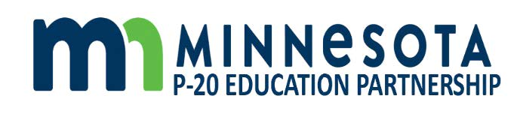

Minnesota P20 Education Partnership
January 21, 2021
2:30pm-4:30pm

- Welcome and Opening
Related Materials
- P-20 Education Partnership 2021 Report

- Update on the Military Compact and the MIC3 response to military education during the pandemic

- Next Steps
  - Developing our workplan
  - Identifying committees/work groups
  - Meeting calendar

- Other

Next Meeting: March 18, 2021
2:30pm-4:30pm

