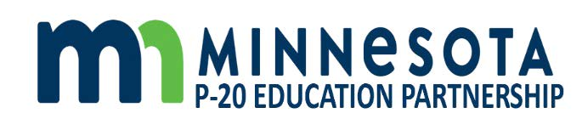

Minnesota P-20 Education Partnership
March 18, 2021
2:30pm-4:30pm

- Welcome and Opening

- COVID-19 impacts and response across P-20

- Learning Session: People for PSEO

- Action Planning Next Steps
  - Workgroup formation and charge
  - Timelines
  - Outcomes and Goals

- Other

Next Meeting: May 20, 2021
2:30pm-4:30pm

