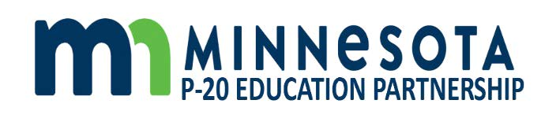

Minnesota P20 Education Partnership
November 19, 2020
2:30pm-4:30pm

- Welcome and Opening

- Update on the Military Compact and the MIC3 response to military education during the pandemic

- Continued review and discussion of preliminary recommendations for our ongoing work
  - Feedback on draft recommendations
  - Next Steps

Related Materials
- Document 4 - Draft Recommendations for MN P-20 Partnership
(NOTE: this is the same PowerPoint presentation shared at our October 22, 2020 meeting)

- Other

Next Meeting: January 7, 2021
1:00pm-2:00pm

