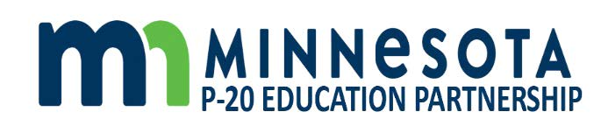

Minnesota P20 Education Partnership
October 22, 2020
2:30pm-4:30pm

- Welcome and Opening

- COVID-19 impacts and response across P20

- Learning Session: The Changing Role of Education in the Automated Workplace

- The Learner Lifespan – final workgroup report and discussion of key questions:
  - What are your key reflections and takeways from the information?
  - Which of the metrics are most important in achieving our purposes?
  - How do the proposed metrics resonate with the metrics and monitoring frameworks used by your organization and stakeholders?

Related Materials
- Document 1 - Telling the Minnesota Story - Learner Lifespan Workgroup Final Report Overview (PowerPoint)
- Document 2 - Telling the Minnesota Story Using Data - Summary Overview (pdf file)
- Document 3 - Telling the Minnesota Story - Learner Lifespan Workgroup Final Report (pdf file)

- Review and discussion of preliminary recommendations for our ongoing work:
  - What are your initial reactions to the preliminary recommendations?
  - What’s missing?

Related Materials
- Document 4 - Draft Recommendations for MN P-20 Partnership (PowerPoint)

- Other

Next Meeting: November 19, 2020
2:30pm-4:30pm

