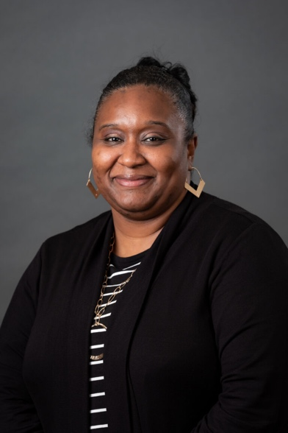

Dr. Tremekia K. Priester
Compact Commissioner Designee
MIC3 South Carolina

Dr. Tremekia K. Priester grew up in the small town of Kingstree, SC just walking distance from the SC Army National Guard 1052nd Transportation Company. The community in which Dr. Priester grew up actively supported and participated in humanitarian efforts for the local area in support of the 1052nd Transportation Company. Dr. Priester has two uncles who are veterans, who have served in the US Army, and one uncle who served in the US Air Force. Dr. Priester’s husband, Jevon Priester, is also a veteran having served in the US Army.
Dr. Priester holds a Bachelor of Science in Elementary Education, a Master of Education in Divergent Learning, an Education Specialist degree in Educational Leadership, and a Doctoral degree in Educational Leadership, Organization, and Instruction. She has been working in the field of education for 23 years, having taught elementary grades second and fifth, serving as an assistant principal and interim principal. Dr. Priester also served as an assistant principal for a middle and high school alternative education program. Dr. Priester was appointed as South Carolina’s Interstate Compact Commissioner Designee in 2019, where she still currently serves. Dr. Priester has received four military challenge coins in recognition of her work within the educational community in support of military-connected students and families.
When she is not working on behalf of military students and families, Dr. Priester enjoys traveling with her family, retail therapy, crafting, and attending extracurricular activities for her 10-year-old daughter, Abigail.

