Purple Up! Social Media Posts

Below are caption ideas to go along with the sample Purple Up! Posts to post throughout the month of April.

Week #1: “During the month of April, we honor our military children,” said Laura Anastasio MIC3 Chairman and Connecticut Compact Commissioner. “We acknowledge that they must adapt and overcome the hardships of transitioning due to the multiple moves they must make while serving alongside their families. This month is our opportunity to celebrate their strength, courage, and resiliency as well as to show our deep appreciation for their sacrifices.” #purpleup4militarykids
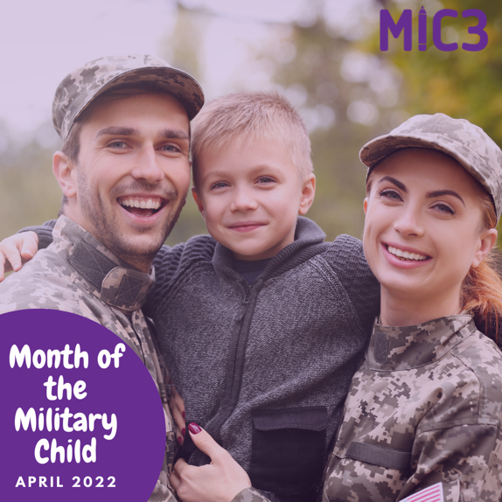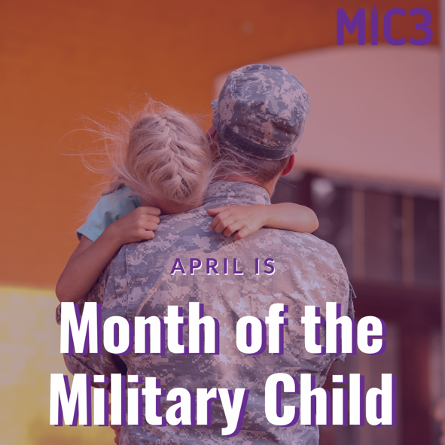

Week #2: Join us in wearing purple to show support for all the military kids for the strength and sacrifices that they have made. Purple represents the joint service operations and is a combination of Army Green, Air Force Blue, Coast Guard Blue, Marine Red, and Navy Blue; it is the appropriate color to represent military children from all branches. #purpleup4militarykids
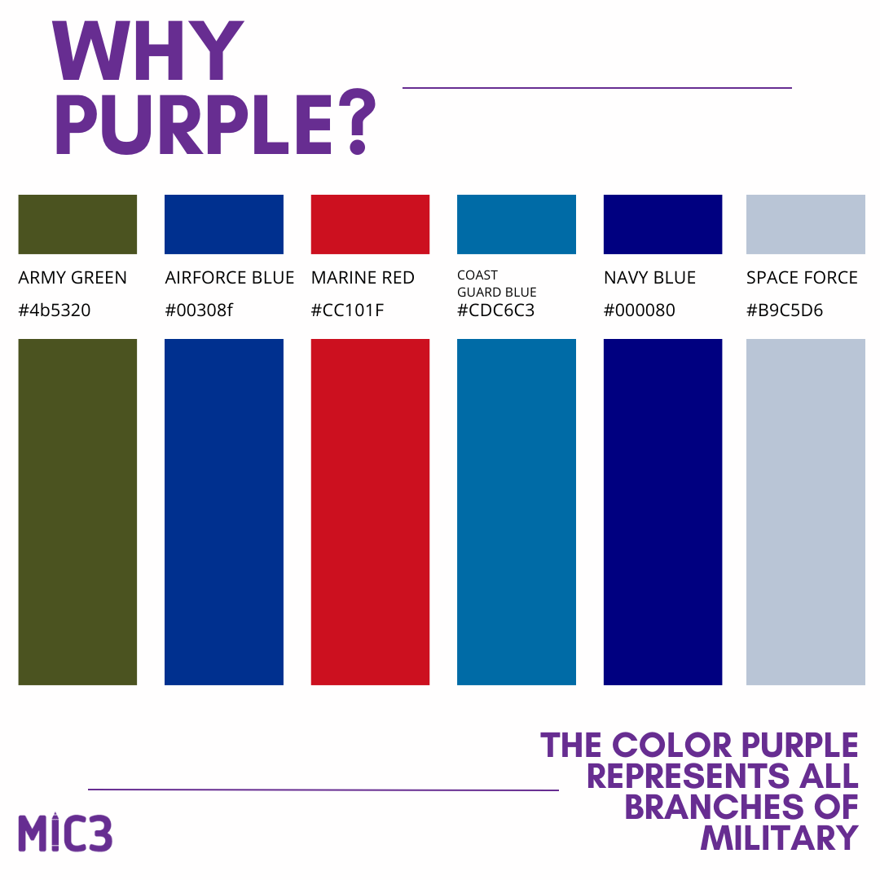

Week #3: 7 Days until we Purple Up! Who are you going to be purpling up for? Comment below and let us know! #purpleup4militarykids
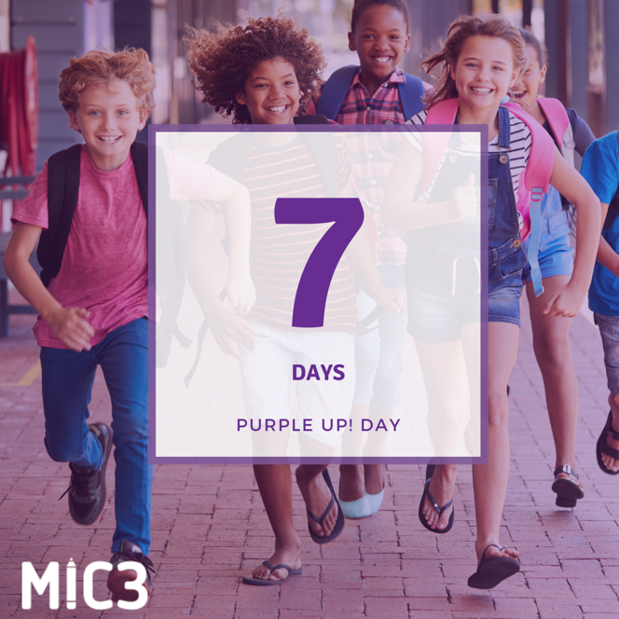

Week #4: Today, everyone is encouraged to wear purple to show support for military children who overcome so many challenges #purpleup4militarykids
