Purple Up! Social Media Posts

Sample Purple Up! Posts to post throughout the month of April.

Week #1: “During the month of April, we honor our military children,” said Ernise Singleton MIC3 Chairman and Louisiana Compact Commissioner. “We acknowledge that they must adapt and overcome the hardships of transitioning due to the multiple moves they must make while serving alongside their families. This month is our opportunity to celebrate their strength, courage, and resiliency as well as to show our deep appreciation for their sacrifices.” #purpleup4militarykids #MIC3Compact
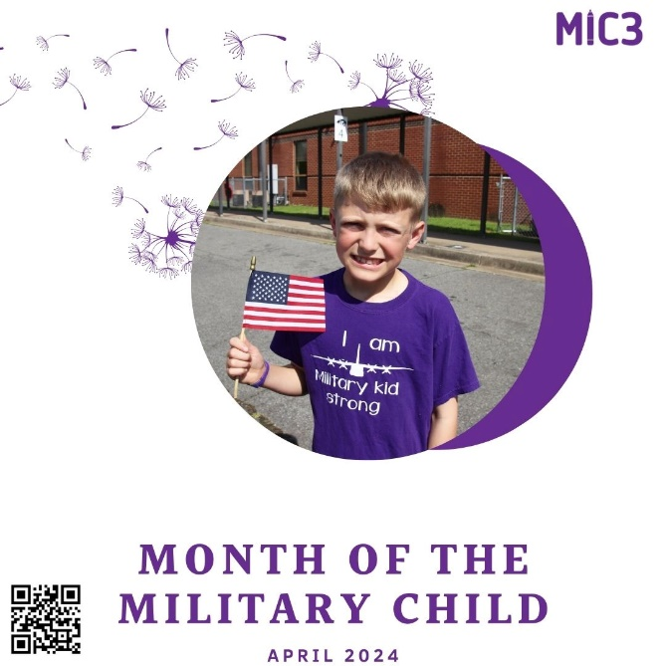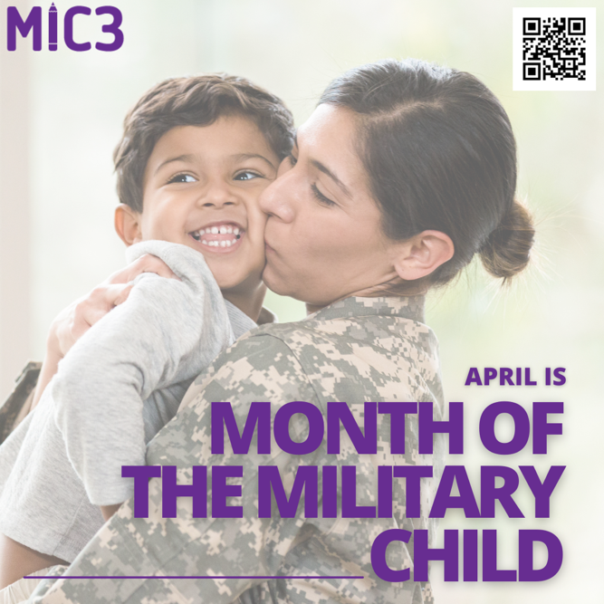

Week #2: Join us in wearing purple to show support for all the military kids for the strength and sacrifices that they have made. Purple represents the joint service operations and is a combination of Army Green, Air Force Blue, Space Force Blue, Coast Guard Blue, Marine Red, and Navy Blue; it is the appropriate color to represent military children from all branches. #purpleup4militarykids #MIC3Compact
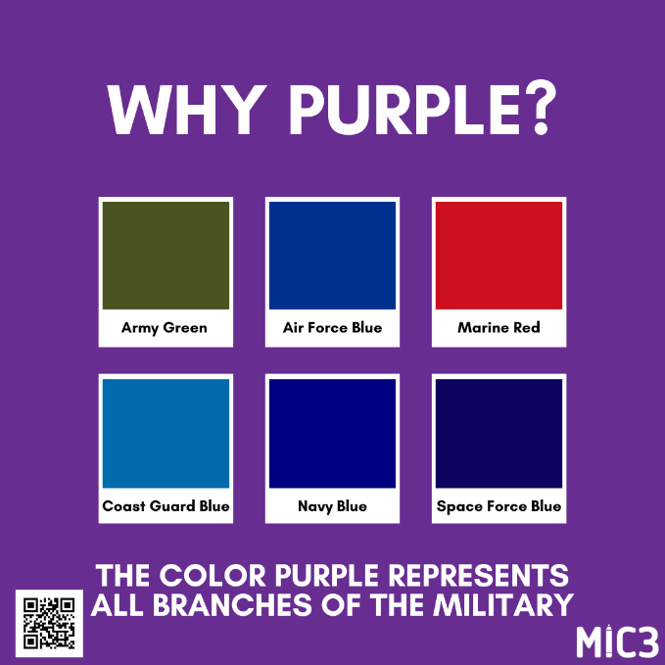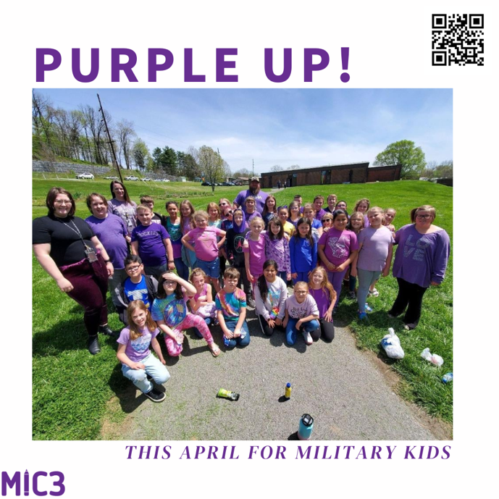

Week #3: Still need some ideas on how to Purple Up! this month? Check out our Purple Up! Toolkit. #purpleup4militarykids #MIC3Compact
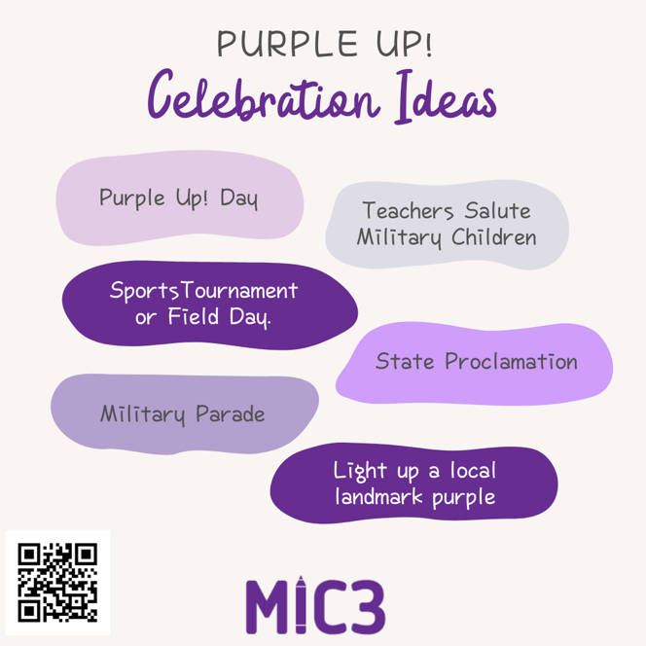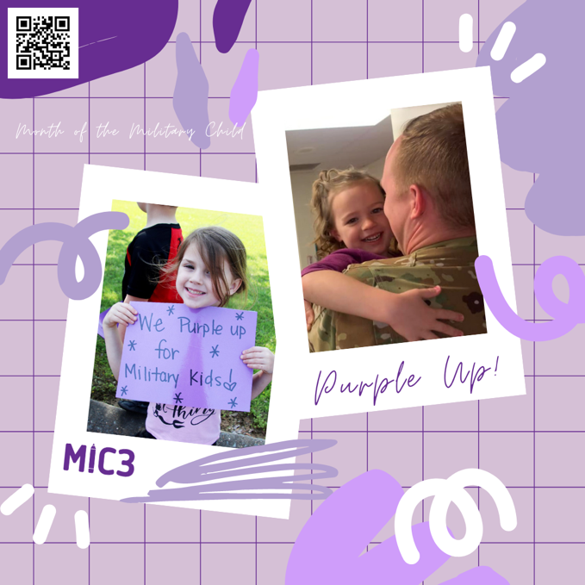

Week #4: Today, everyone is encouraged to wear purple to show support for military children who overcome so many challenges #purpleup4militarykids #MIC3Compact
